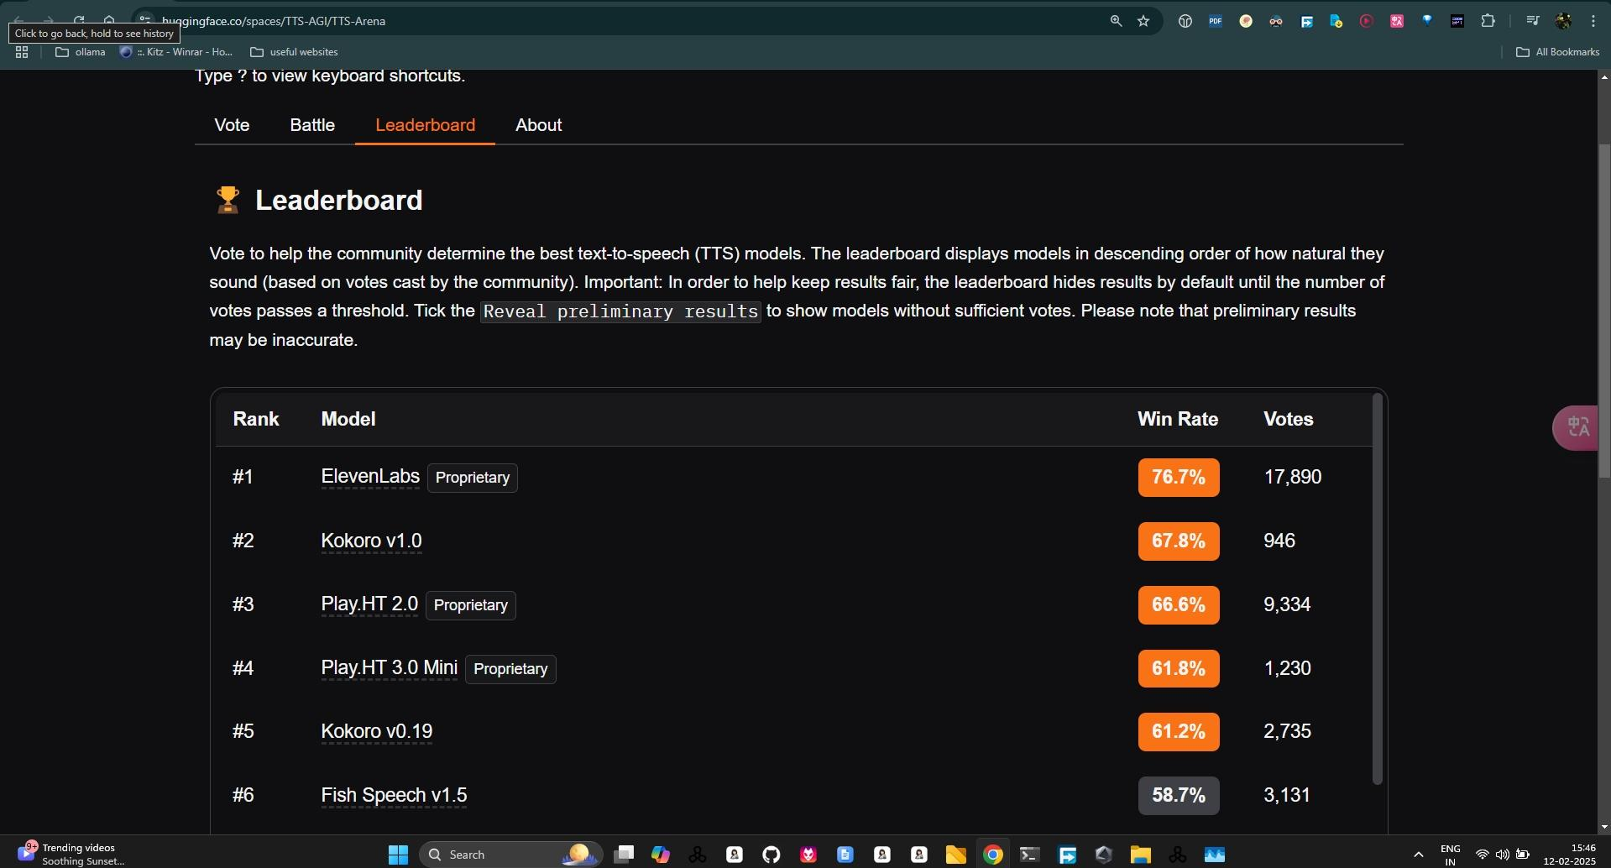

,

,

,

**Kokoro has 3k likes in hugging face,**

**Trending in Hugging face,**

,

<https://youtu.be/fQ2CfDAl2Og?si=dtbsloskH74VSdv0>

**I installed kokoro using above video, it’s working,**

**Option to download audio is available,**

**Its GUI**

**1)**

**So I uploaded above video to Jio Cloud, terabox**

**, Hugging face**

**2)**

**Zip file used to download kokoro ( 1.9 GB) is uploaded to terabox , Jio Cloud , Hugging face**

**,**

<https://huggingface.co/gokul9/kokoro-tts/tree/main>

,

**Instead of searching for audiobooks just use text to speech model to create audiobooks**

,

Copy text of 6 or more pages of pdf or ebooks or epub at a time

Then convert text to speech,

Then listen

,

,

,

<https://github.com/mirbehnam/Kokoro-TTS-windows>

**How to Use**  
Download the ZIP file.  
Extract it to your desired location.  
Run run_kokoro.bat to launch the app.  
Open your browser and enjoy the easy-to-use interface!

,